***Image Segmentation***

Image segmentation is the front-stage processing of image compression. In general, we hope that there are three advantages in image segmentation. The first is the speed..When segmenting an image, we do not want speed much time to do it. The second is good shape connectivity of its segmenting result. When segmenting an image, we do not want the result of segmenting shape to be fragmentary. If the result of segmenting shape is fragmentary, we need take many resources to record the boundaries of the over-segment results. It is not we want to get the results. The third is good shape matching. Consequently, it will be reliable.

Image segmentation can be classified three categories traditionally including

**1**. Threshold Technique

**2**. Region-Based Image Segmentation

**3**. Edge-Based Image Segmentation.

1. **Threshold Technique**

Thethreshold technique is simplest in segmenting methods. To set two thresholds on the histogram of the image, we can classify between the two thresholds in the histogram as the same region and classify the others as the second region.

**Multi-level thresholding through a statistical recursive algorithm**

Multilevel thresholding for image segmentation through a statistical recursive algorithm is proposed in [9]. The algorithm is used in segmenting an image into multi-level by using mean and variance. The method can be made use of dealing with colored images or images of complex background, and then can do what bi-level doesn’t it.

Multi-level thresholding algorithm:

1. Repeat steps 2~6, *n*/2-1 times; where *n* is the number of thresholds.

2. Range ***R*** = [*a*, *b*]; initially set a = 0 and b = 255.

3. Find mean () and standard deviation () of all the pixels in ***R***.

4. Sub-ranges’ boundaries  and  are calculated as  and; where  and  are free parameters.

5. Pixels with intensity values in the interval [*a*, ] and [, *b*] are assigned threshold values equal to the respective weighted means of their values.

6. , .

7. Finally, repeat step 5 with  and with.

Using the algorithm can the compute the PSNR (peak signal to noise ratio). After applying the algorithm a few times, we can find the PSNR to be saturated. By the property, we can get the appropriate number of thresholds *n.*

1. **Region-base Image Segmentation**

**a)Data clustering**

Data clustering is one method of Region-Based image segmentation, and it is popularly used mathematics and statistics. We can use the centroids or prototypes to present the great numbers of cluster to achieve the two goals of reducing the computational time consuming and providing a better condition to compress it.

In general, data clustering can be classified two kinds of system including hierarchical clustering and partitional clustering. In the hierarchical clustering, we can change the numbers of cluster during the process. However, in the partitional clustering, we must decide the numbers of cluster before processing.

**1.Hierarchical clustering**

For the hierarchical clustering, it has an advantage of simple concept. It is roughly classified two kinds of algorithms including hierarchical agglomerative algorithm and hierarchical divisive algorithm.

Hierarchical agglomerative algorithm:

1. Let every single data point (pixel or image) in the whole image as a cluster.
2. Look for the shortest distance of two data pointin the whole image, and merge them to become a new cluster.
3. Repeat the step 1 and step 2 until the numbers of cluster attain our demand.

We can use many ways to define the distance here.

Hierarchical divisive algorithm:

1. Let the whole image as a cluster.
2. Look for the biggest diameter of the cluster groups.
3. If , split  out as a new clusterand see the rest data points of  as .
4. If, split  out as .
5. Back to step 2 and continue the algorithm until  and  is not changed anymore.

The diameter of a cluster  as The diameter is defined as .

the mean of distance between  and every single point in cluster .

Using the method of hierarchical clustering, the result is characteristic of strong correlation with the original image. Therefore, it will be reliable. Nevertheless, it has a fatal defect of computational time consuming, then it cannot be used for the large image.

**2.Partitional clustering**

In the partitional clustering, we must decide the numbers of cluster before processing. The K-means algorithm is most well-known in the partitional clustering.

K-means algorithm:

1. Decide the numbers of the cluster  and choose randomly  data points ( pixels or image) in the whole image as the  centroids in  clusters.
2. Find out nearest centroid of every single data point (pixel or image) and classify the data point into that cluster the centroid located. After doing step 2, all data points are classified in some cluster.
3. Calculate the centroid of every cluster.
4. Repeat step 2 and step 3 until it is not changed.

Using the K-means algorithm, it has an advantage of less computing time. In other words, the partitional clustering is faster than the hierarchical clustering. However, the different initial centroids will bring about the different results which means the K-means algorithm has an initial problem. In order to solve the initial problem, we can choose to use one initial point or use the Particle Swarm Optimization (PSO).

**Region growing**

Region growing is simplest in region-base image segmentationmethods.The concept of region growing algorithm is check the neighboring pixels of the initial seed points, then determine whether those neighboring pixels are added to the seed points or not. Therefore, it is an iterative process.

Region growing algorithm:

1. Choose the seed points.
2. If the neighboring pixels of the initial seed points are satisfy the criteria such as threshold, they will be grown. The threshold can be intensity, gray level texture, and color…etc.

We use the criteria of the same pixel value in Fig, then check the neighboring pixels of the initial seed points. If their pixel values are identical with seed points, they can be added to the seed points. It is stop until there is no change in two successive iterations. We use 4-connected neighborhood to grow the neighboring pixels of the initial seed points here.

|  |  |  |  |  |
| --- | --- | --- | --- | --- |
| 1 | 1 | 9 | 9 | 9 |
| 1 | 1 | 9 | 9 | 9 |
| 5 | 1 | 1 | 9 | 9 |
| 5 | 5 | 5 | 3 | 9 |
| 3 | 3 | 3 | 3 | 3 |

|  |  |  |  |  |
| --- | --- | --- | --- | --- |
| 1 | 1 | 9 | 9 | 9 |
| 1 | 1 | 9 | 9 | 9 |
| 5 | 1 | 1 | 9 | 9 |
| 5 | 5 | 5 | 3 | 9 |
| 3 | 3 | 3 | 3 | 3 |

|  |  |  |  |  |
| --- | --- | --- | --- | --- |
| 1 | 1 | 9 | 9 | 9 |
| 1 | 1 | 9 | 9 | 9 |
| 5 | 1 | 1 | 9 | 9 |
| 5 | 5 | 5 | 3 | 9 |
| 3 | 3 | 3 | 3 | 3 |

(a) original image (b) step 1 (c) step2

|  |  |  |  |  |
| --- | --- | --- | --- | --- |
| 1 | 1 | 9 | 9 | 9 |
| 1 | 1 | 9 | 9 | 9 |
| 5 | 1 | 1 | 9 | 9 |
| 5 | 5 | 5 | 3 | 9 |
| 3 | 3 | 3 | 3 | 3 |

|  |  |  |  |  |
| --- | --- | --- | --- | --- |
| 1 | 1 | 9 | 9 | 9 |
| 1 | 1 | 9 | 9 | 9 |
| 5 | 1 | 1 | 9 | 9 |
| 5 | 5 | 5 | 3 | 9 |
| 3 | 3 | 3 | 3 | 3 |

|  |  |  |  |  |
| --- | --- | --- | --- | --- |
| 1 | 1 | 9 | 9 | 9 |
| 1 | 1 | 9 | 9 | 9 |
| 5 | 1 | 1 | 9 | 9 |
| 5 | 5 | 5 | 3 | 9 |
| 3 | 3 | 3 | 3 | 3 |

(d) step 3 (e) step 4 (f) step5

Fig. An example of region growing.

**Region merging and splitting**

Region merging and splitting is a developing algorithm in segmenting the images [4]. It is used to differentiate the homogeneity of the image.

Region merging and splittingalgorithm:

1. Splitting step:

We choose the criteria to split the image based on quad tree. At the same time, we can determine the numbers of splitting levels gradually.

1. Merging step:

If the adjacent regions satisfy the similarity properties, we will merge them.

1. Repeat step 2 until it is not changed.

In the below Fig., it is an example of region merging and splittingalgorithm. We use the splitting criteria and the merging criteria of the locating total area of one section. We split the image until get the resolution we need. In fig. (a), (b), (c) and (d) show the splitting part and Fig. (e) and (f) show the merging part.

splt_merge_robot3splt_merge_robot2splt_merge_robot1

(a) Original Image (b) Splitting: stage 1 (c) Splitting: stage 4

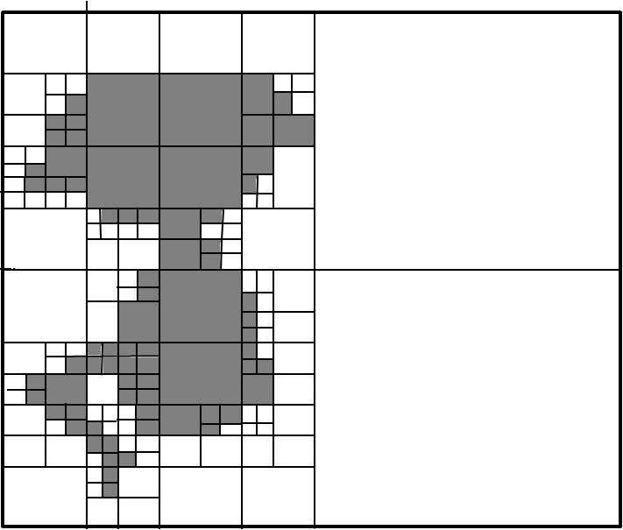splt_merge_robot4splt_merge_robot4

(d) Splitting: stage 5 (e) Merging: stage 5 (f) Merging result

Fig. The example of region merging and splitting.

The quad tree-based segmentation has the problem of the blocky segmentation as DCT image compression.

**Edge detection**

Edge detection and corner detection discuss recently in digital image processing. Image segmentation can be regard as progress of edge detection. The watershed image segmentation is an example of edge-based image segmentation.

**Point detection and line detection**

The action of the point detection is used to detect the difference between a single pixel and the adjacent pixel.

**3.Edge-Based Image Segmentation**

**Watershed image segmentation:**

Watershed image segmentation can be regarded as an image in three dimensions (two spatial coordinates versus intensity). We will use three types of point which “minimum”, “catchment basin”, and “watershed line” to express a topographic interpretation. There are two properties of continuous boundaries and over-segmentation in watershed image segmentation. Because watershed image segmentation has the disadvantage of over-segmentation, we use the maker to improve it.

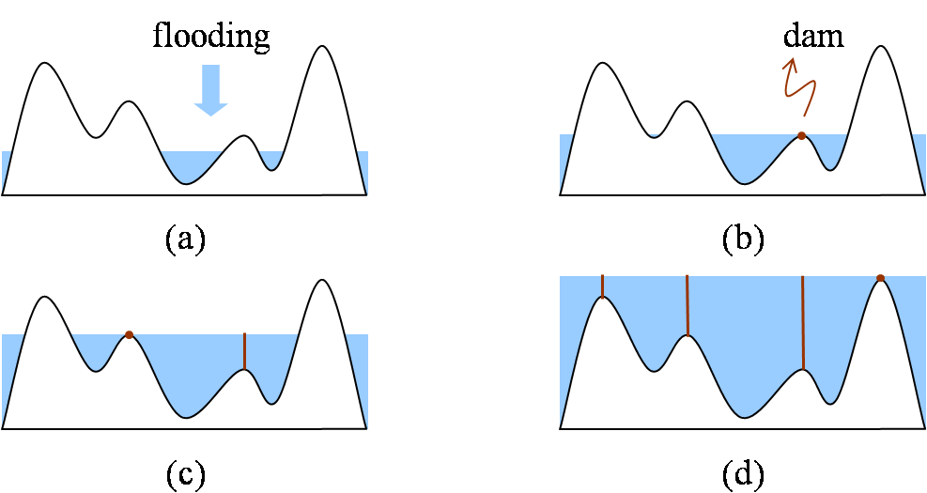

Fig:Watershed algorithm

Watershed algorithm with using marker:

1. Use a smoothing filter to preprocess the original image, then the action can minimize the large numbers of small spatial details.
2. Use two markers (internal markers and the external markers) to define the criteria of markers.
3. 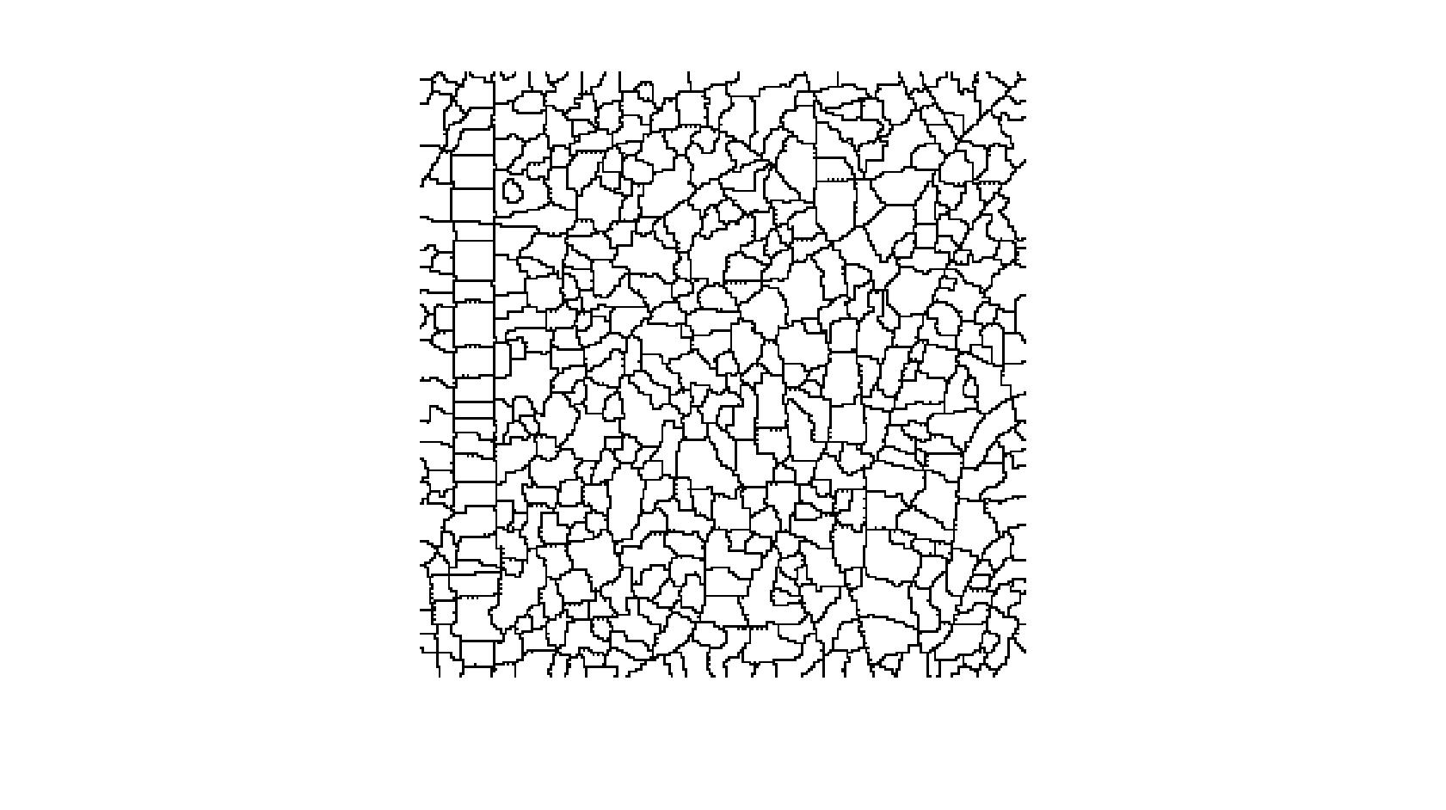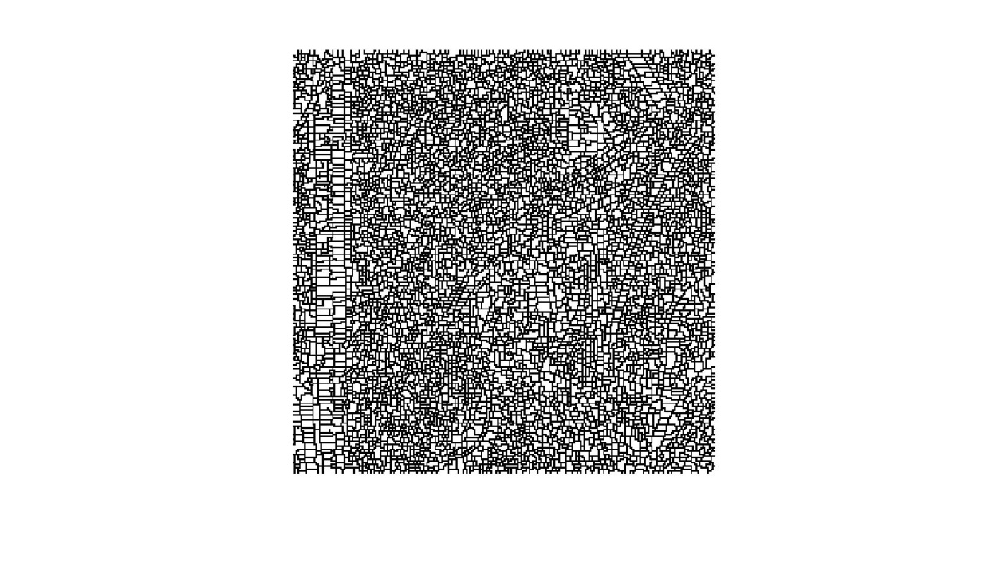 (b)

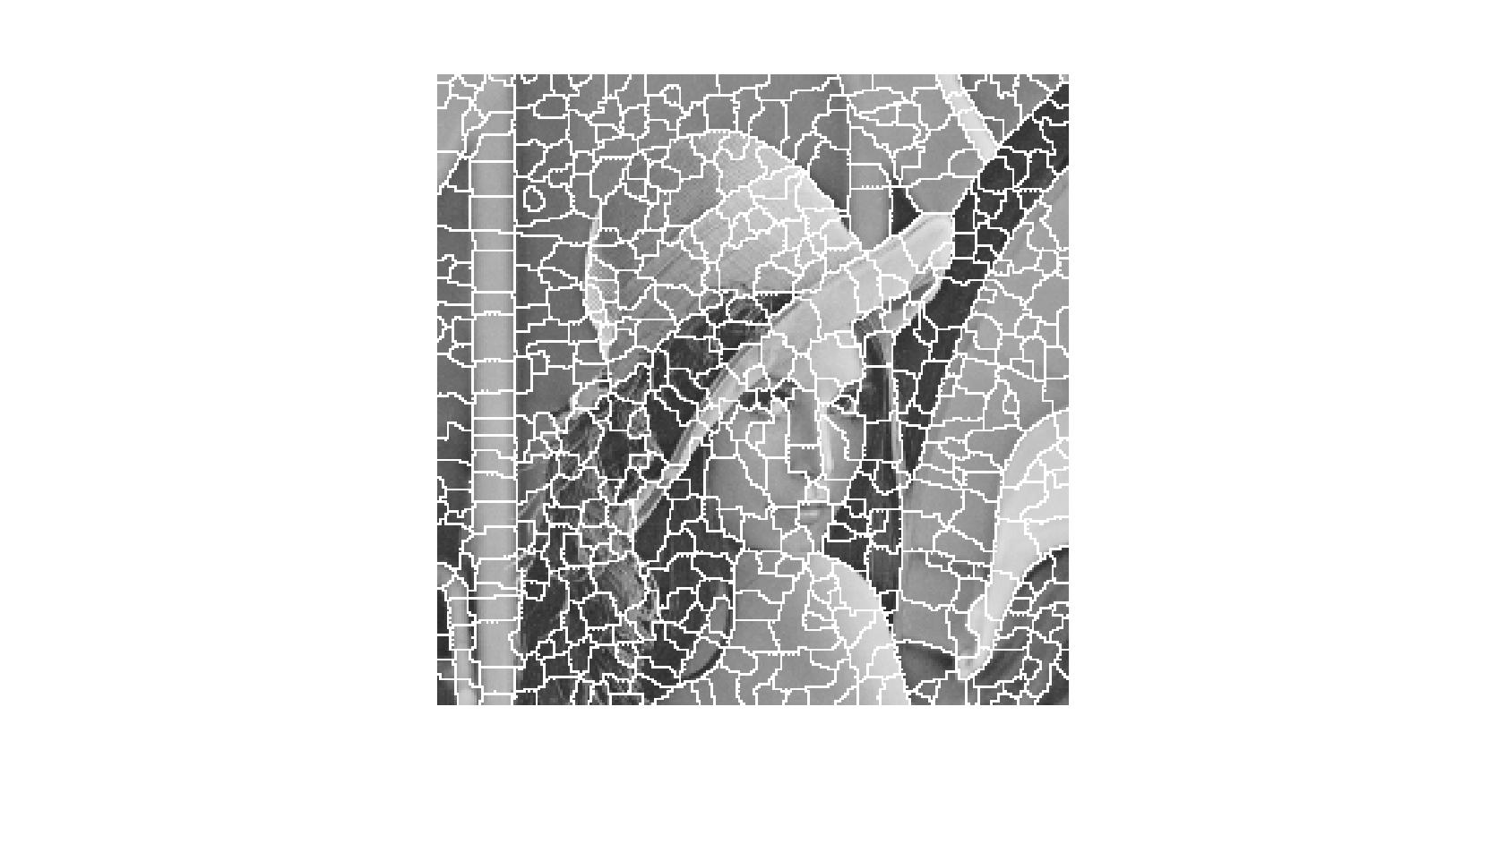

(c)

Fig: The simulation result of Watershed algorithm with MATLAB code; time: 1.23 seconds (a) pure watershed method, (b)(c) watershed method with improvement of gradient method.

The simulation result of watershed algorithm has an advantage that it is fast speed. At the same time, it has a critical over-segmented problem.

* 1. **The comparison of threshold technique and methods of region-based image segmentation and edge-based image segmentation**

|  |  |
| --- | --- |
| **The segmenting methods** | **Advantages** |
| **Threshold technique** | 1. Simplest method in segmenting images. |
| **\*Hierarchical clustering** | 1. The concept is simple. 2. The result is characteristic of strong correlation with the original image. (reliable) |
| **\*Partitional clustering**  **(K-means algorithm)** | 1. Fast speed. 2. The concept is simple, because numbers of cluster is fixed. |
| **\*Region growing** | 1. Can correctly separate the regions of same properties we define. 2. Clear edges, which means the good segmentation results. 3. The concept is simple. 4. Good shape matching of its results. 5. Can determine seed points and criteria 6. Can choose the multiple criteria simultaneously. |
| **\*Region merging and splitting** | 1. We split the image until get the resolution we need. 2. The splitting criteria and the merging criteria can use different criteria. |
| **\*Mean shift** | 1. Can separate the face and shoulders. |
| **△Watershed** | 1. Fast speed. 2. The large numbers of segmented region result is reliable. |

Table: The advantages of threshold technique and methods of region-based image segmentation and edge-based image segmentation.

|  |  |
| --- | --- |
| **The segmenting methods** | **Disadvantages** |
| **Threshold technique** | 1. Not involve the spatial information of the images, so it will bring about noise, blurred edges, or outlier in the images. |
| **\*Hierarchical clustering** | 1. Has a problem of computational time consuming, then it cannot be used for the large image. |
| **\*Partitional clustering**  **(K-means algorithm)** | 1. A problem of choice of numbers of cluster . 2. The different initial centroids will bring about the different results. 3. Cannot show the characteristic of database. |
| **\*Region growing** | 1. Has a problem of computational time consuming 2. Cannot differentiate the fine variation of the images. |
| **\*Region merging and splitting** | 1. Computation is extensive. 2. Has the problem of the blocky segmentation. |
| **\*Mean shift** | 1. Has a problem of computational time consuming  2. Cannot separate the other sections except the face and shoulders. |
| **△Watershed** | 1. Over-segmentation. |

Table: The disadvantages of threshold technique and methods of region-based image segmentation and edge-based image segmentation.

\*: means one method of region-based image segmentation.

△: means one method of edge-based image segmentation..

APPLICATIONS :

\* Medical imaging.

\* Recognition tasks.

\* EKSU on Google Maps.

\* Computer guided surgery.

\* Object detection such as face detection,

brake detection etc.

\* Traffic control systems.

\* In sport scenes.

\* Content-based image retrieval.

\* Video surveillance.